1. Go through the documentation- <https://developer.chrome.com/docs/devtools/overview/>
2. View and change CSS exercise <https://developer.chrome.com/docs/devtools/css/>

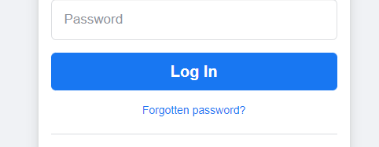

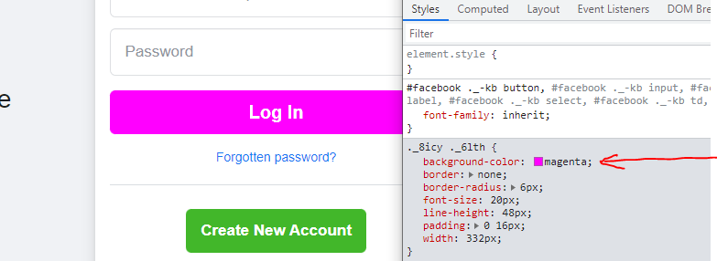

1. Go through Inspect CSS grid section, CSS flexBox layout from the documentation

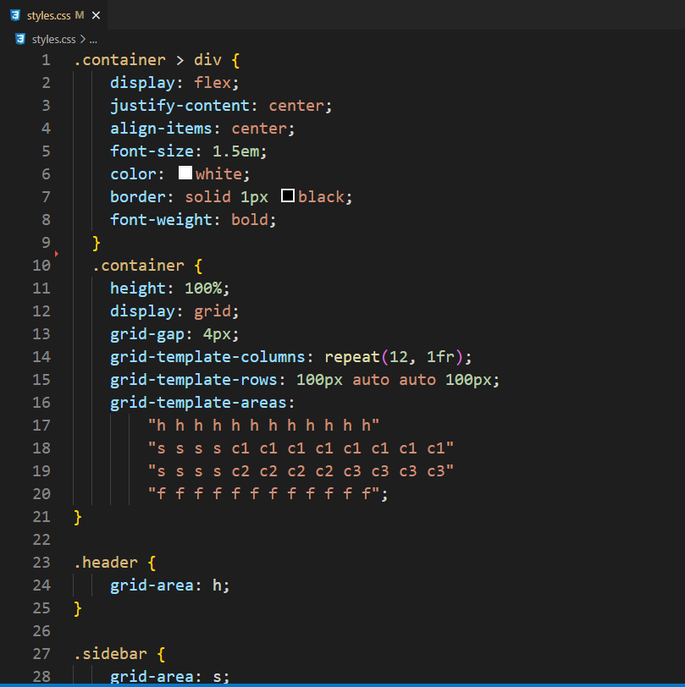

1. Whatever javascript you know, implement a short demo in console

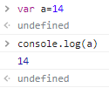

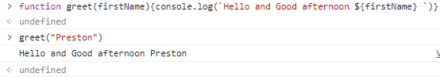

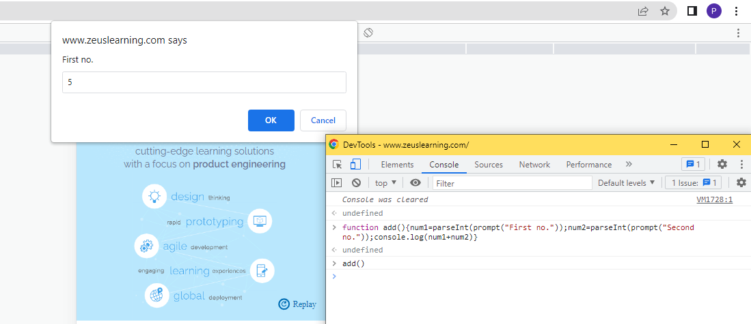

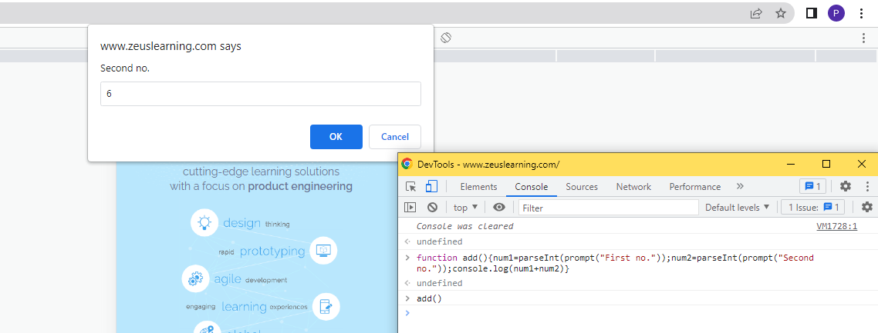

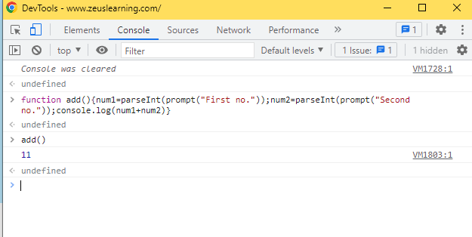

1. Modify the page using query selectors

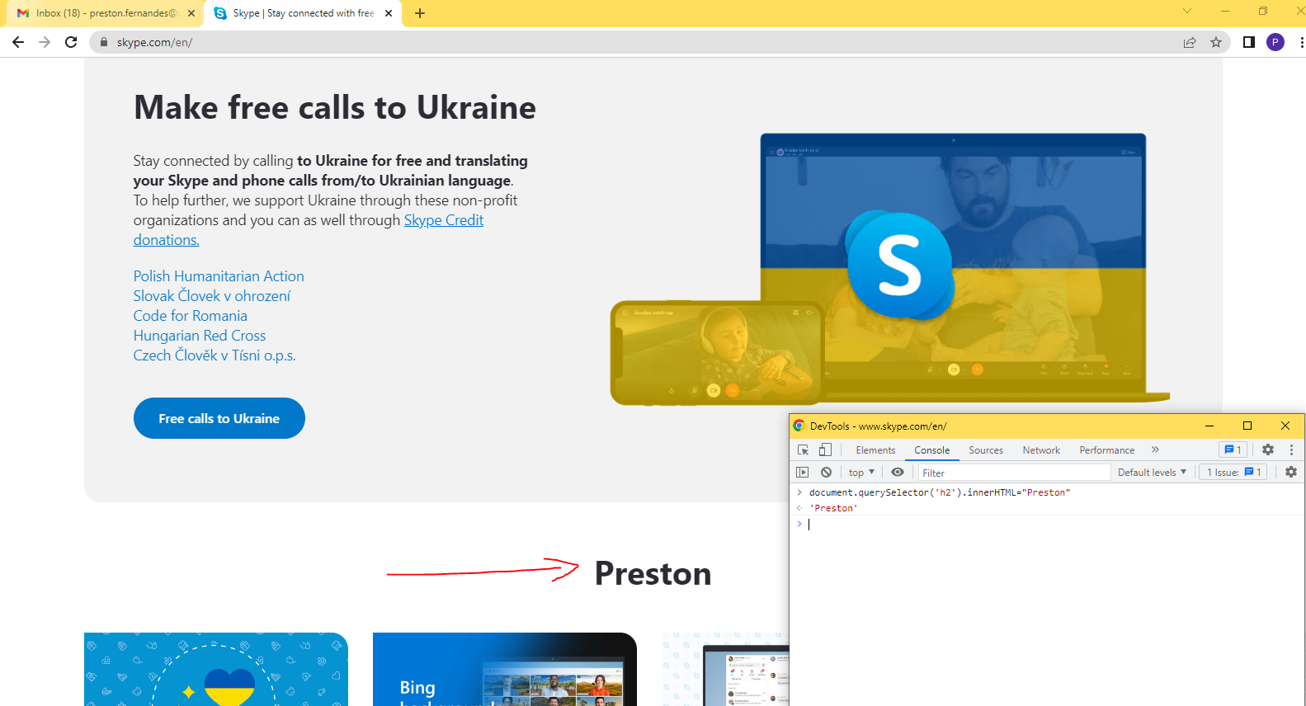

1. Login to any page, try to logout without clicking on the logout button

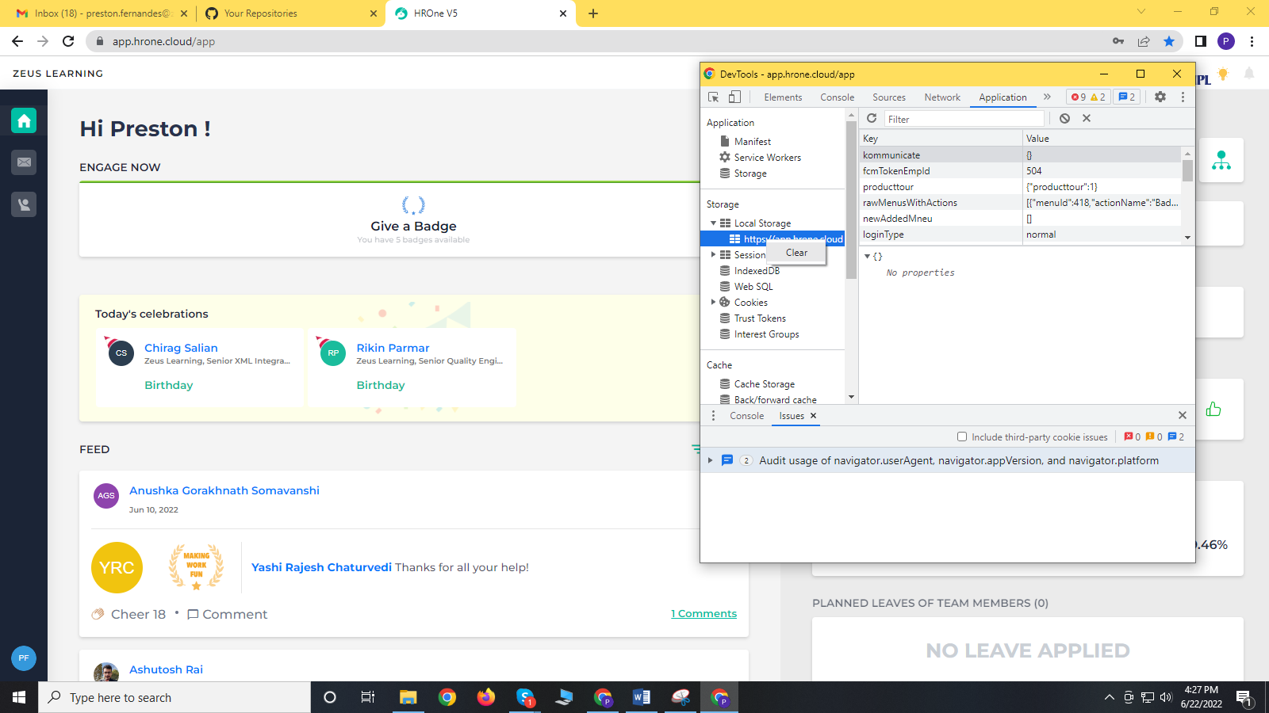

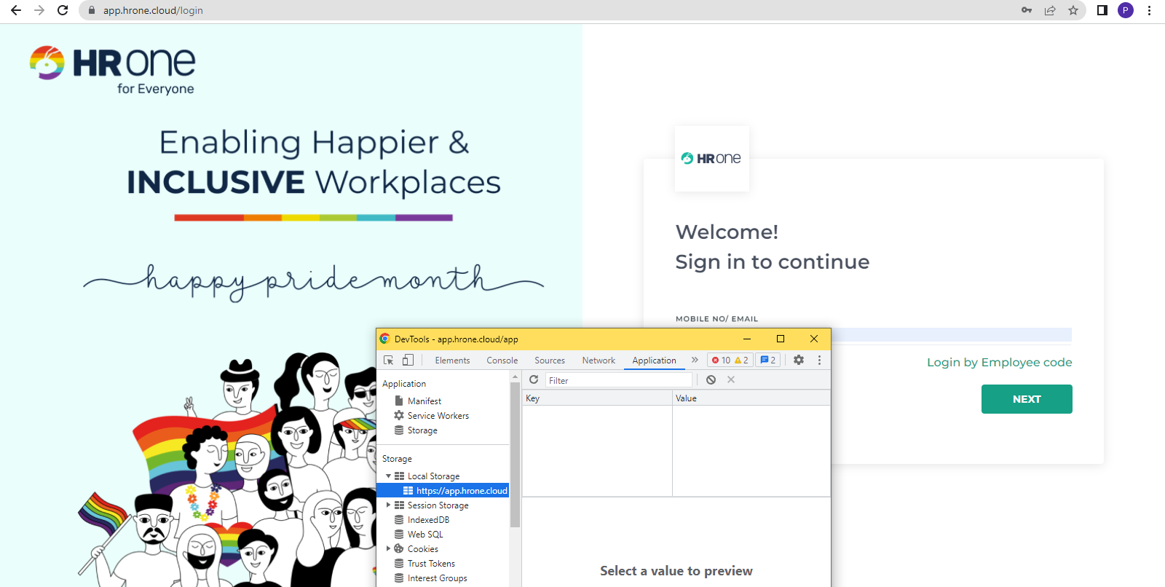

1. Go to facebook.com and list all the CSS that are applied to the sign up button

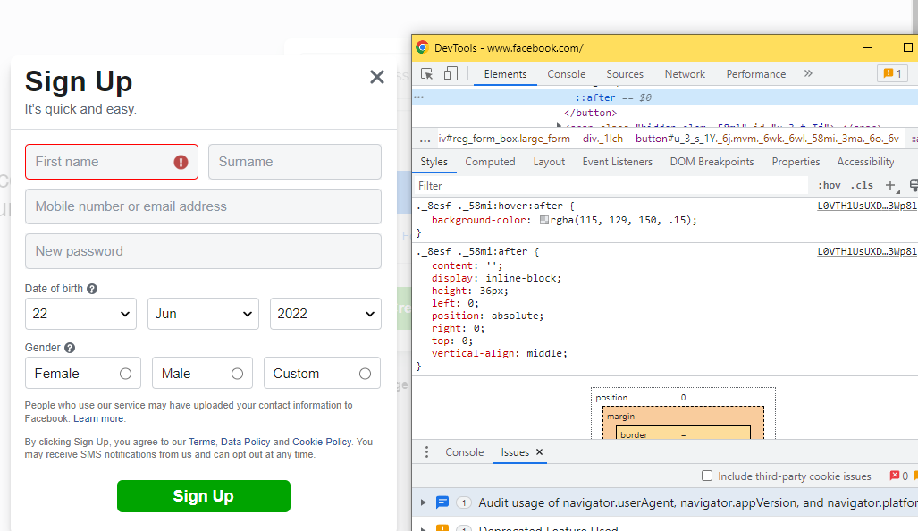

._8esf ._58mi {

font-family: SFProDisplay-Bold, Helvetica, Arial, sans-serif!important;

}

._8esf ._58mi {

background: none;

background-color: #00a400;

border: none;

border-radius: 6px;

box-shadow: none;

color: #fff;

font-size: 18px;

height: 36px;

overflow: hidden;

padding: 0 32px;

text-shadow: none;

}

._3ma {

font-weight: bold!important;

letter-spacing: normal;

text-rendering: optimizelegibility;

}

._58mi {

min-width: 194px;

padding: 7px ;

text-align: center;

}

._6j {

cursor: pointer;

display: inline-block;

}

.mvm {

margin-top: 10px;

margin-bottom: 10px;

}

button {

margin: 0;

}

user agent stylesheet

button {

appearance: auto;

writing-mode: horizontal-tb !important;

font-style: ;

font-variant-ligatures: ;

font-variant-caps: ;

font-variant-numeric: ;

font-variant-east-asian: ;

font-stretch: ;

word-spacing: normal;

text-transform: none;

text-indent: 0px;

align-items: flex-start;

box-sizing: border-box;

}

body {

background: #fff;

direction: ltr;

margin: 0;

padding: 0;

unicode-bidi: embed;

}

._8esf ._58mi:after {

content: '';

display: inline-block;

height: 36px;

left: 0;

position: absolute;

right: 0;

top: 0;

vertical-align: middle;

}

**References:**

<https://www.w3schools.com/jsref/met_document_queryselector.asp>